Welcome Screen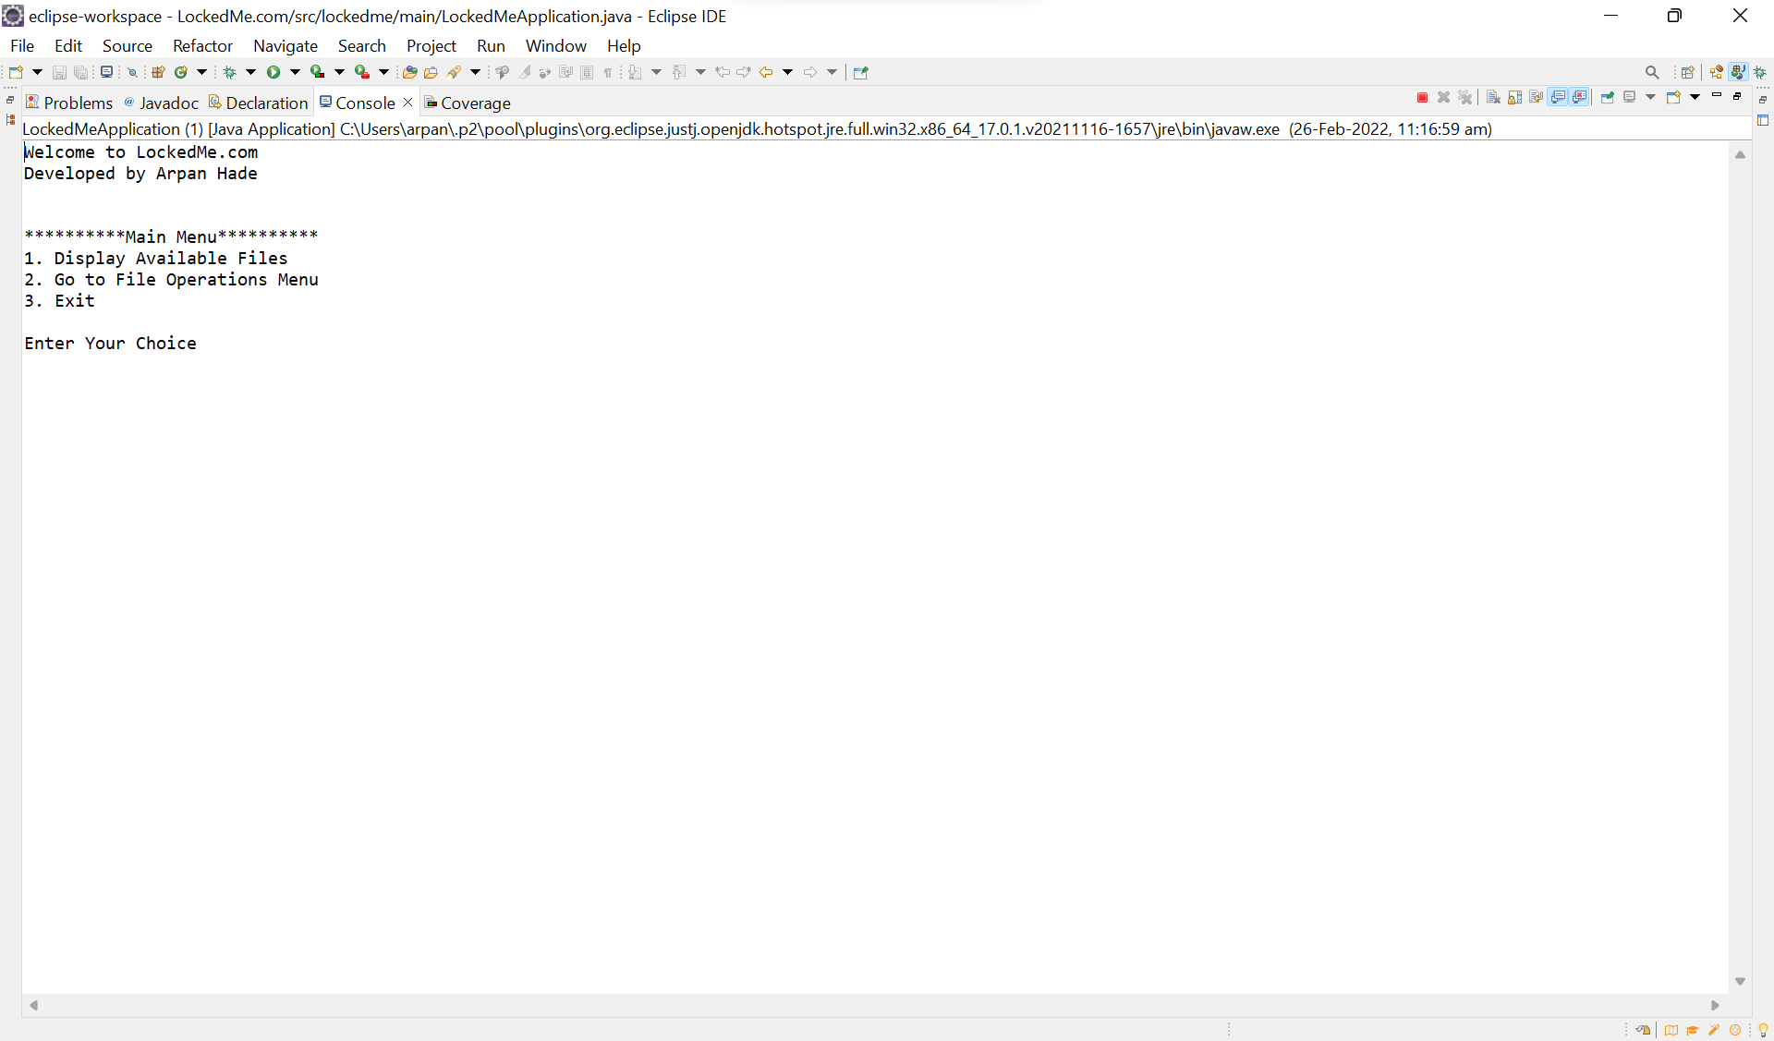

Main Menu: Option 1-Display Available Files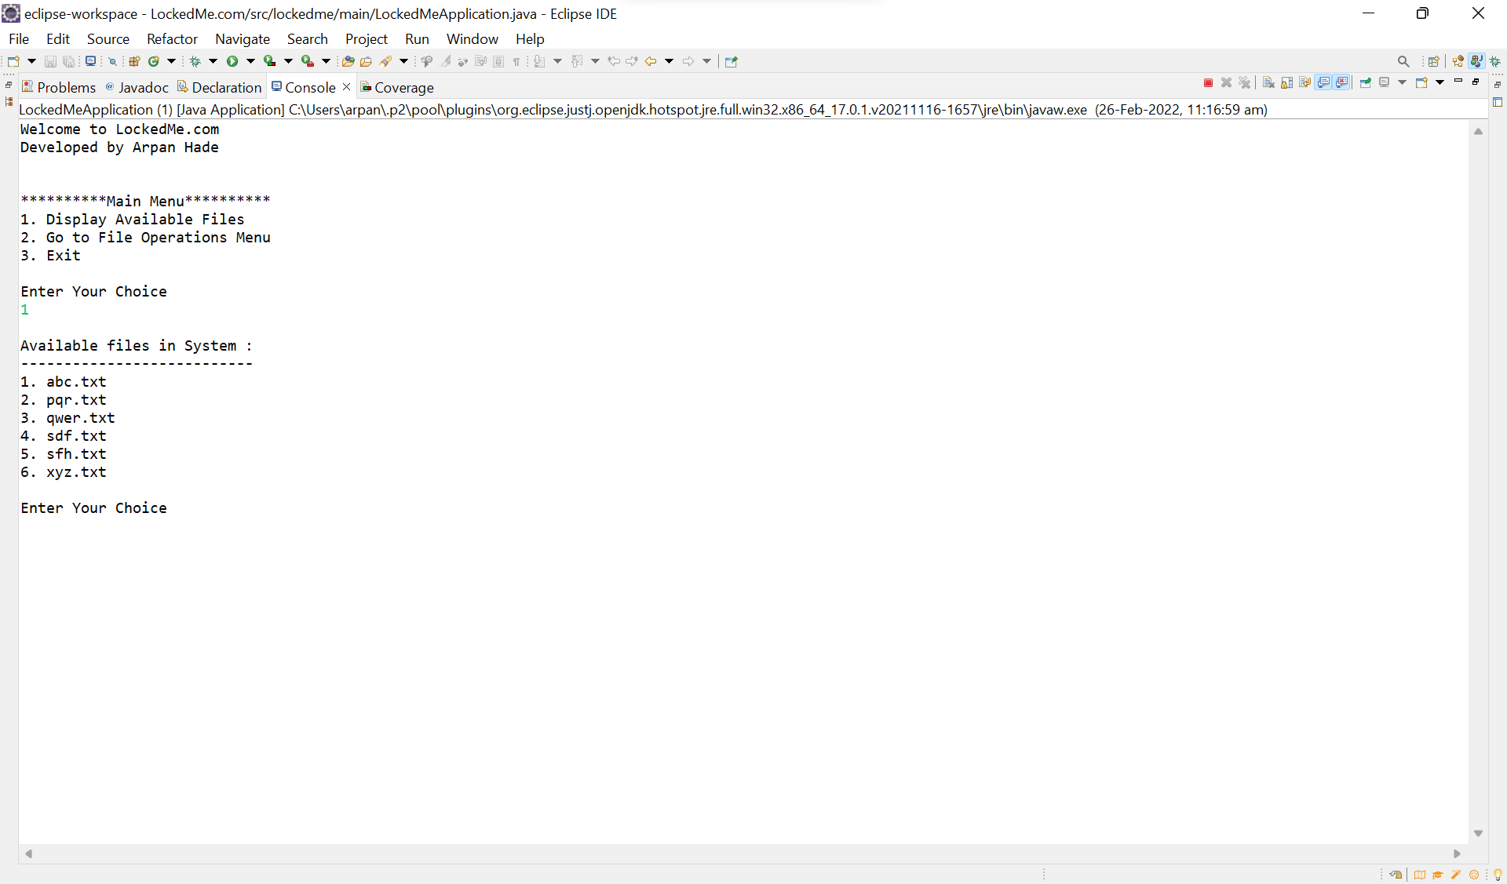 Main Menu: Option 2-Go to File Operation Menu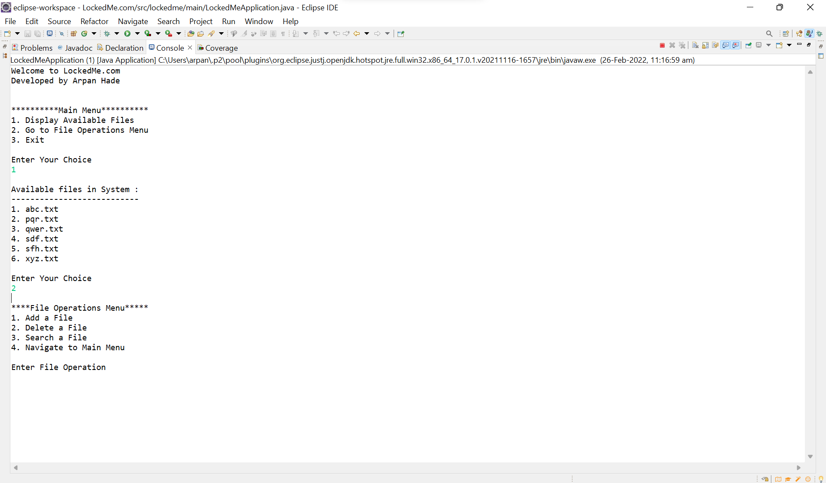 Main Menu: Option 3-Exit 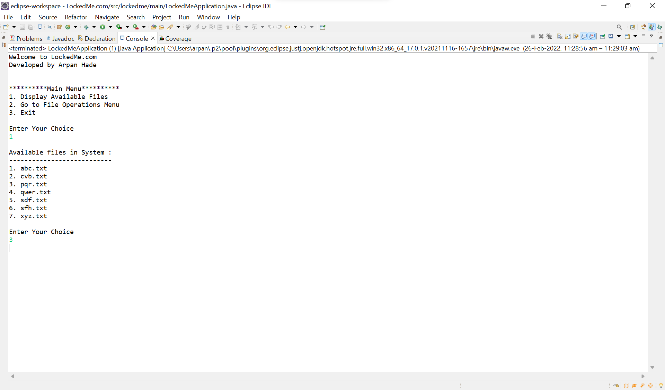

Main Menu: Negative Scenario 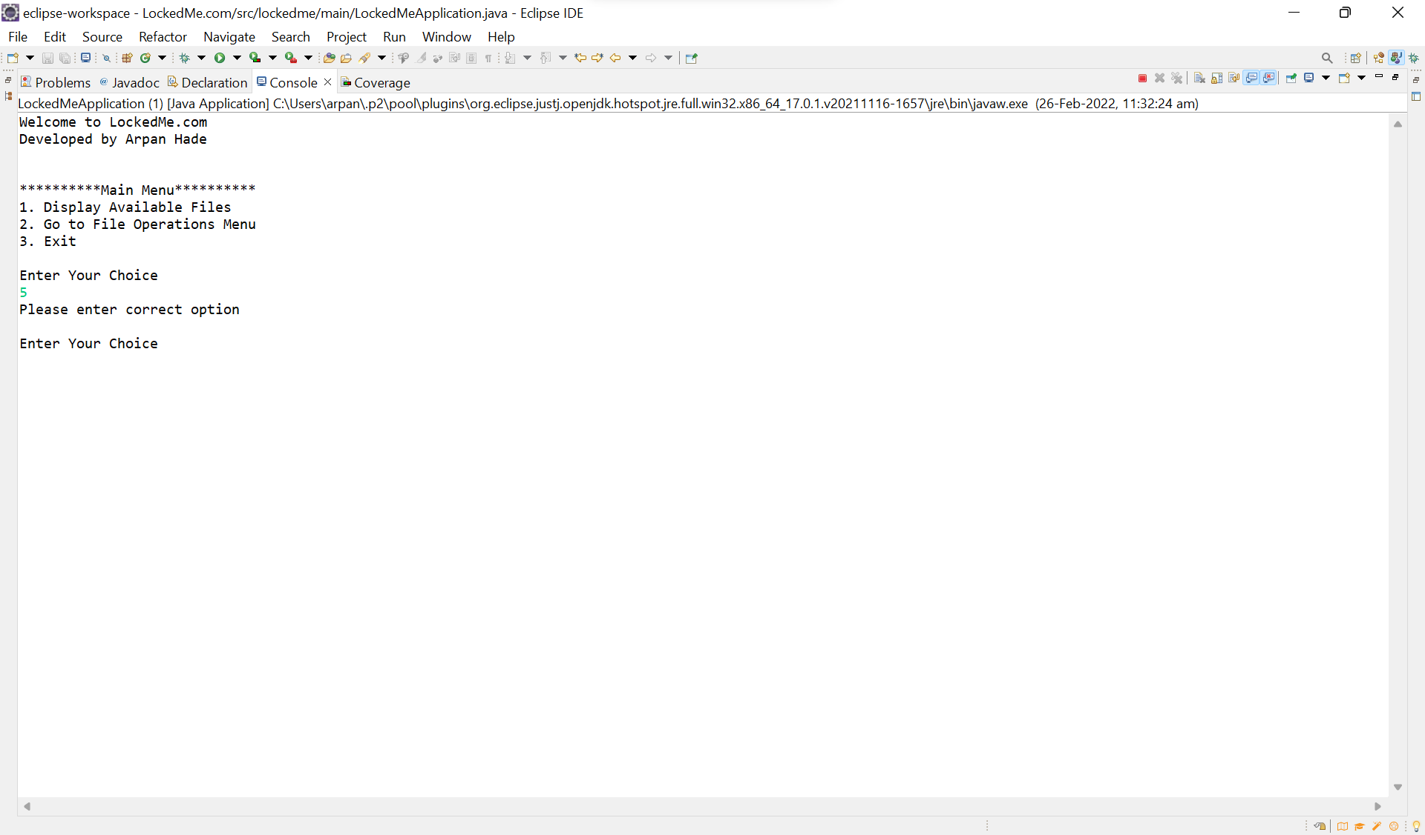 File Operation Menu: Option 1-Add

A.Positive Scenario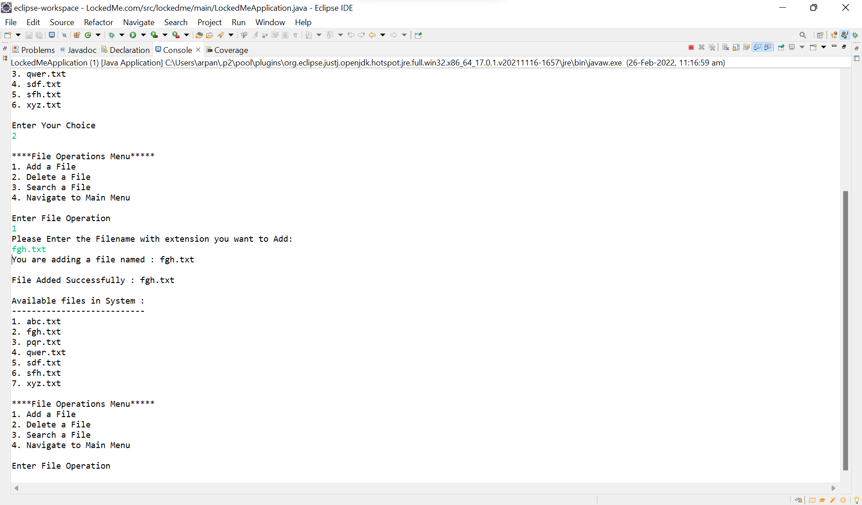

B. Negative Scenario 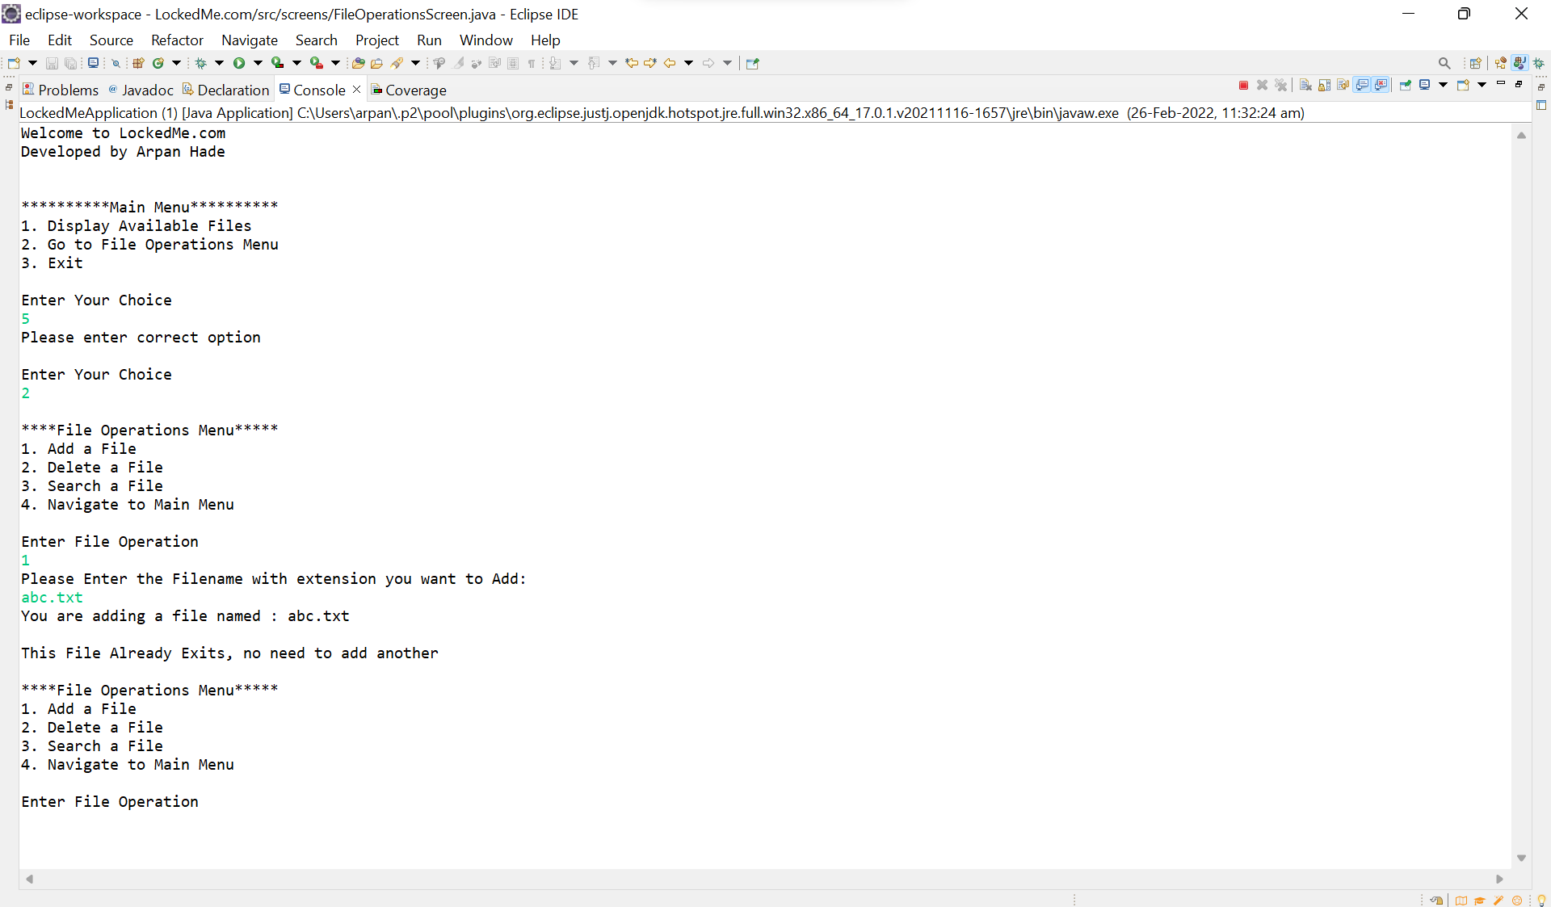File Operation Menu: Option 2-Delete

A.Positive Scenario 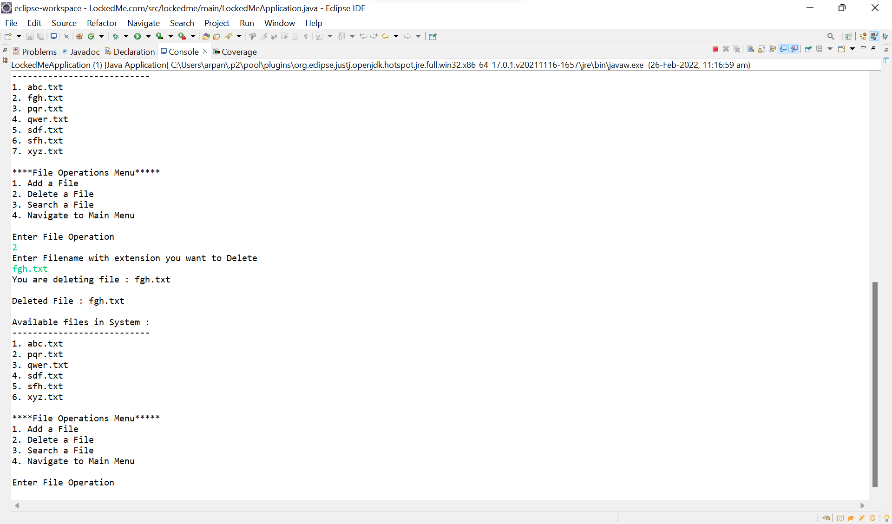 B. Negative Scenario 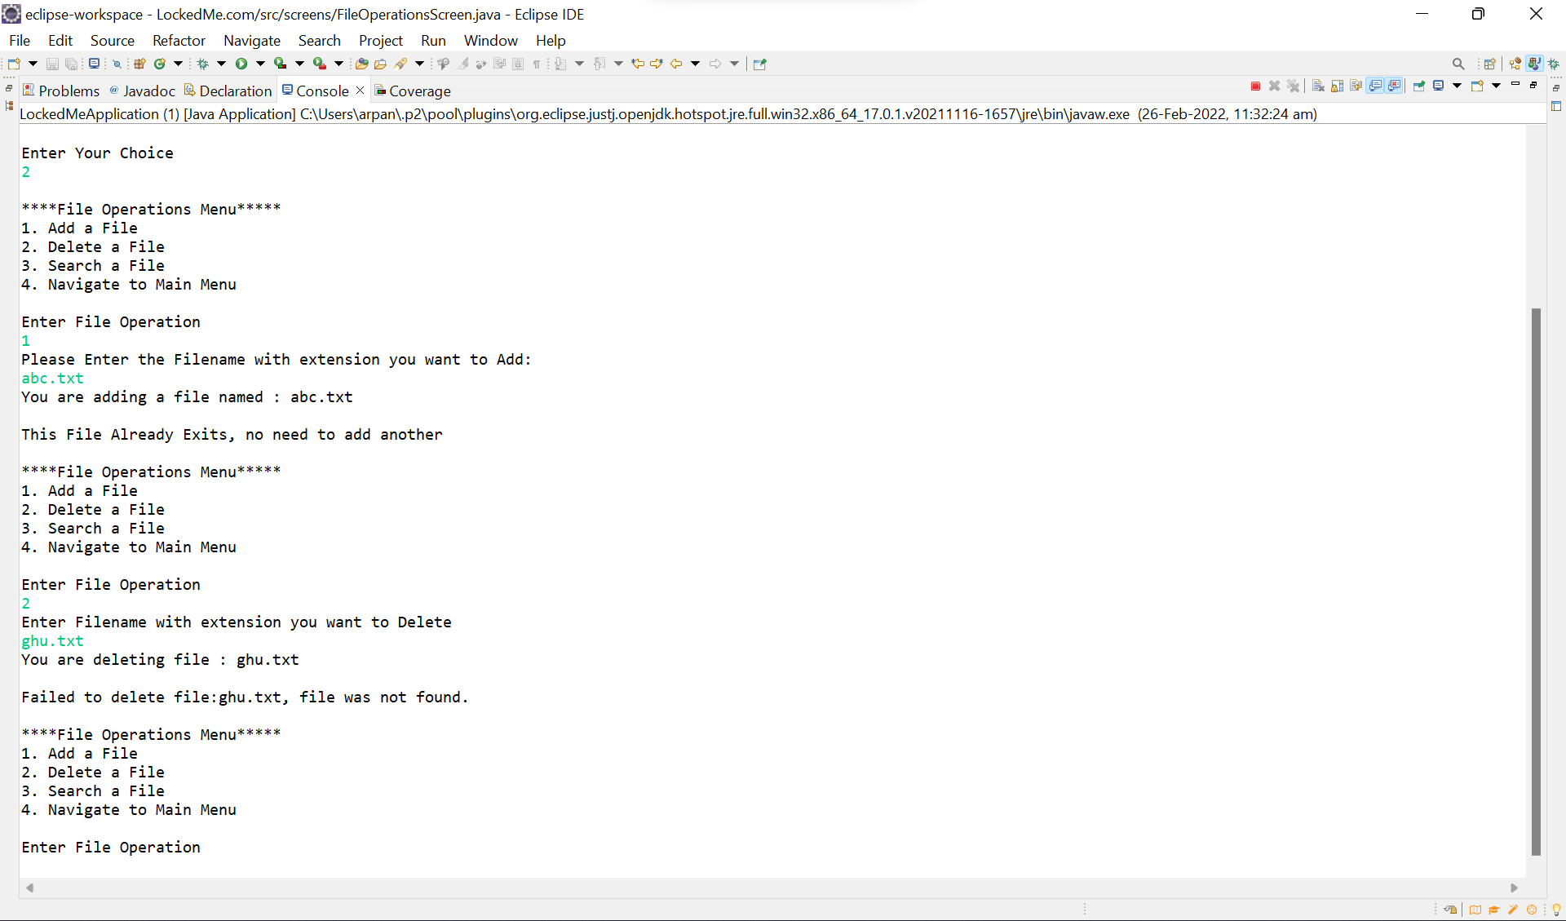

File Operation Menu: Option 3-Search

A.Positive Scenario

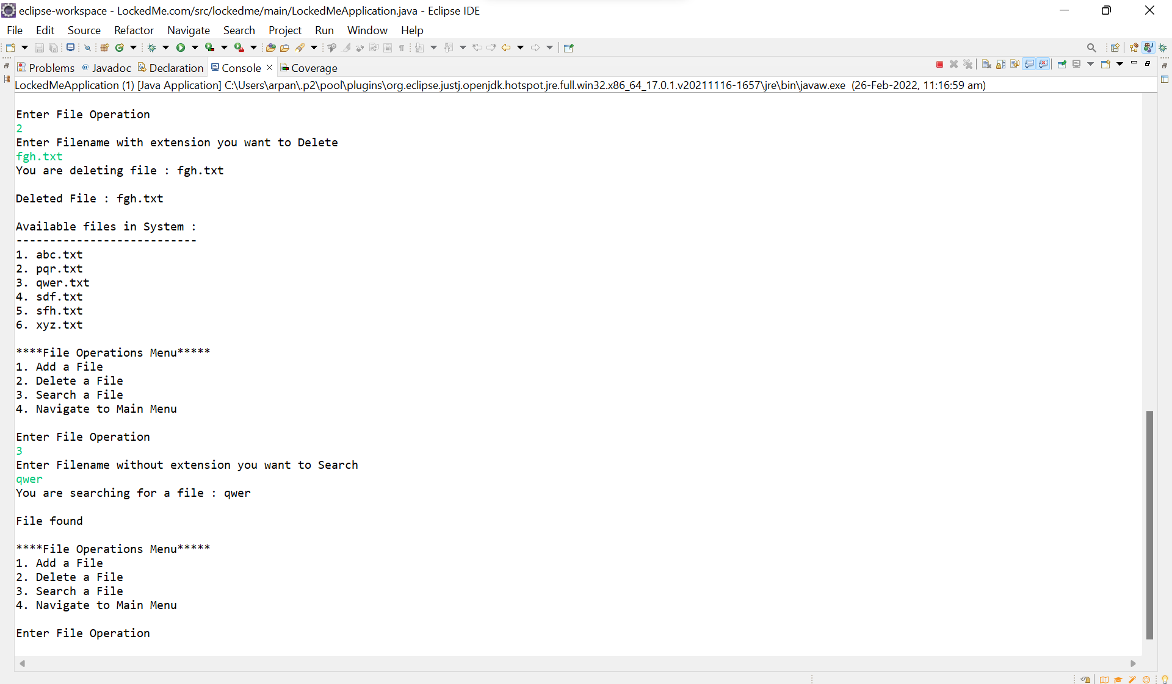 B. Negative Scenario 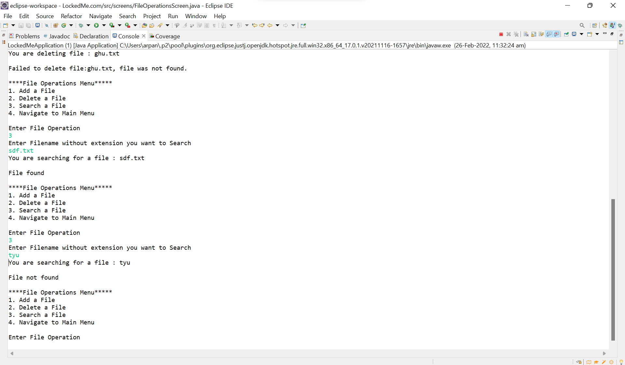

File Operation Menu: Option 4-Navigate to Main Menu 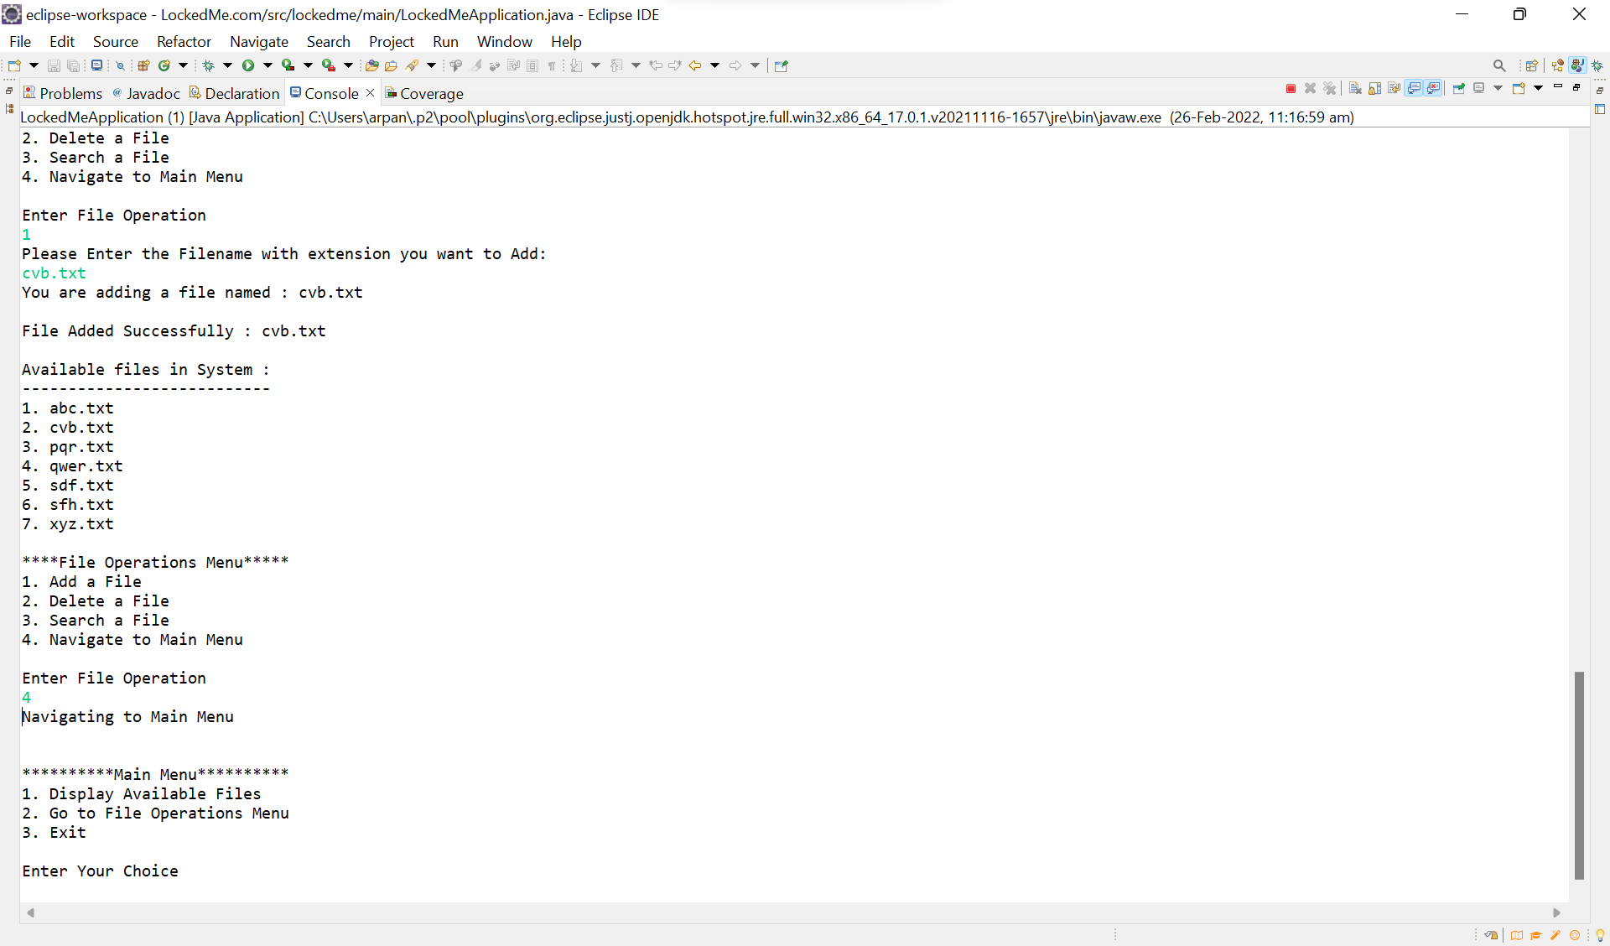 File Operation Menu: Negative Scenario

